
Rolfing® Structural Integration Health Intake Form

Note: This form is used as a guideline for further discussion about your general health and well-being.
Name
Email__________________________________________ Phone number_________________________

Do you have or ever had any medical conditions I should know about? Please describe, including approximate dates of illness and treatment:_________________________________________________
____________________________________________________________________________________

Are you currently under the care of a medical physician, chiropractor or other therapist?
If yes, please describe:
If not, please indicate approximate date of last physical:
What medication(s) have you taken during the last six months?

Please describe, including approximate dates, sites of injuries and treatments:
Past injuries
Past accidents
Past surgeries

Previous bodywork
What would you like to gain from Rolfing Structural Integration?

Where did you learn about Rolfing SI?
Questions prior to beginning:
Please feel free to ask questions at any time during the process. Client communication is vital to the work.

Name:
Date:
Please draw on the diagram below to indicate any places where you have pain, stiffness or discomfort:

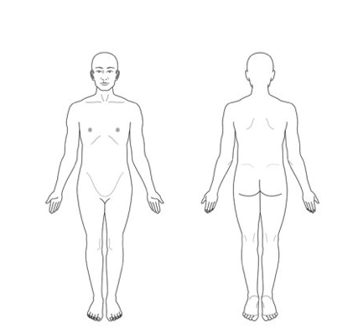

Thank you for taking the time to fill out this questionnaire. It will remain confidential.
I appreciate your continued participation in your own good health.
Please note that cancellations made with less than 24 hours notice will be charged half rate.

